**WORKFLOW AND WORKFLOW ACTION SCRIPT**

1. **Create a workflow for purchase orders where transactions with an amount less than 1000 are automatically approved. For transactions exceeding 1000, the Purchasing Manager should have the button to approve or reject the transaction.**

* I have created three states i.e. Pending Approval, Accepted and Rejected.
* On the Pending Approval state, I have created two buttons i.e. Approve and Reject and Set Field Display Type, Parameters are Approval Status = DISABLED and Condition as User Role!= Administrator, FIN MM – Purchasing Manager.
* Then on the workflow transition to Approved state, I set a condition if Total(amount) < 1000, then it will be auto approved. So set the execute on button to Approve.
* I checked the Do not exit workflow checkbox because as we know when the record in the workflow enters a non-exiting state, the record will remain in the state forever and the workflow will not terminate.
* Then on the Approved state I created a new action as set field value and set the field id to Approval Status. Then set the value to static and select approved from the selection dropdown.
* Then on the workflow transition from Pending Approval to Rejected I set the execute on button to Reject.
* Then on the Rejected state created a new action as set field value and field id to approval status. Then set the value to static and select rejected from the selection dropdown.

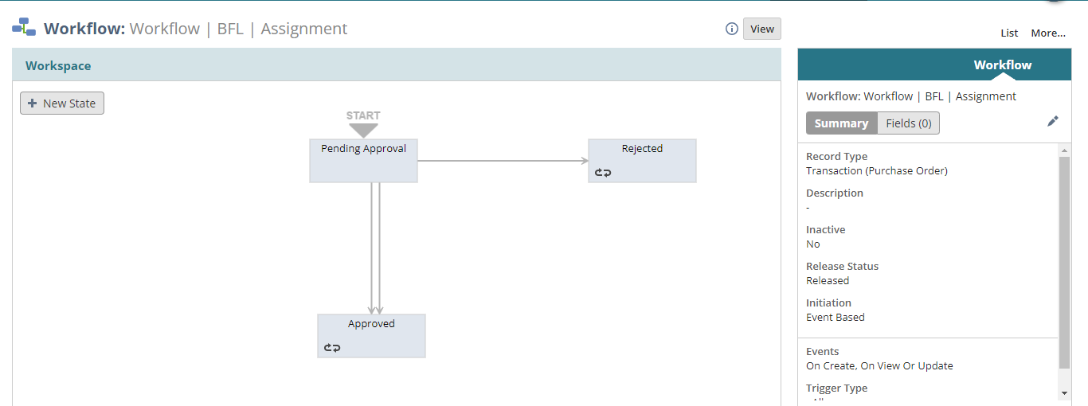Now in the below image as the amount is less than 1000, so it approved automatically.

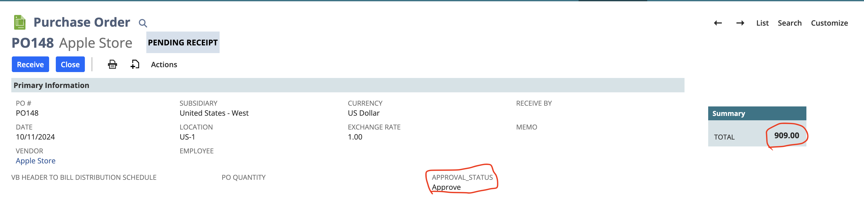And now in the below image you can see the total amount is more than 1000. So, as I have logged in as an administrator role I have two options. I.e. Approve and Reject. Let’s click on reject the status should change to Rejected.

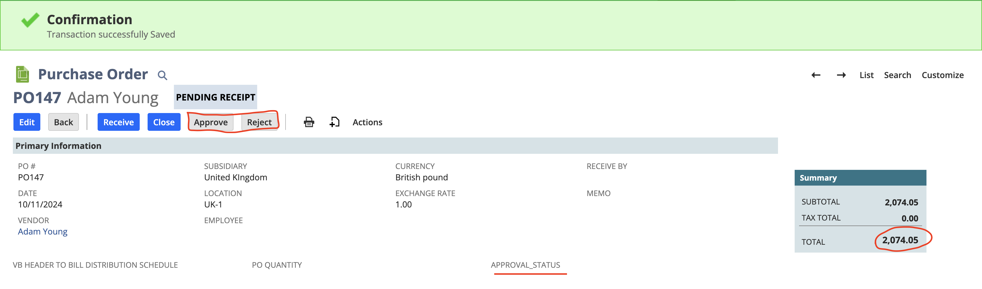Now you can see upon clicking on reject the approval status changed to reject.

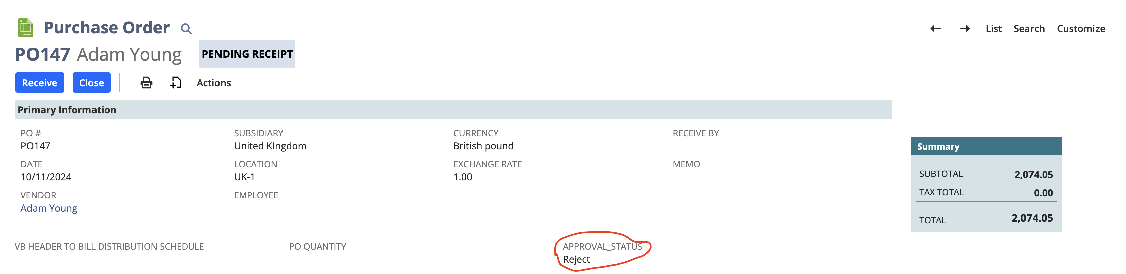

1. **Create a button labeled 'Sync Qty' on the purchase order interface. Upon clicking this button, the total quantity of the purchase order should be populated in a custom field labeled 'PO Qty'. If the quantity exceeds 2, an email should be triggered to the respective vendor to initiate the purchase order creation.**

* Here I have calculated the net item quantity of the purchase order using **workflowActionScript** and using **onAction** entry point.
* Then I returned the integer value as a parameter and set it to the workflow field.
* I have created a custom body field on it and and created a custom button using workflow.
* Then when I click on the Sync Qty button it will set the total quantity in the PO Qunatity field and if the qunatity exceeds two, it will trigger a mail to the respective vendor to initiate the purchase order creation.

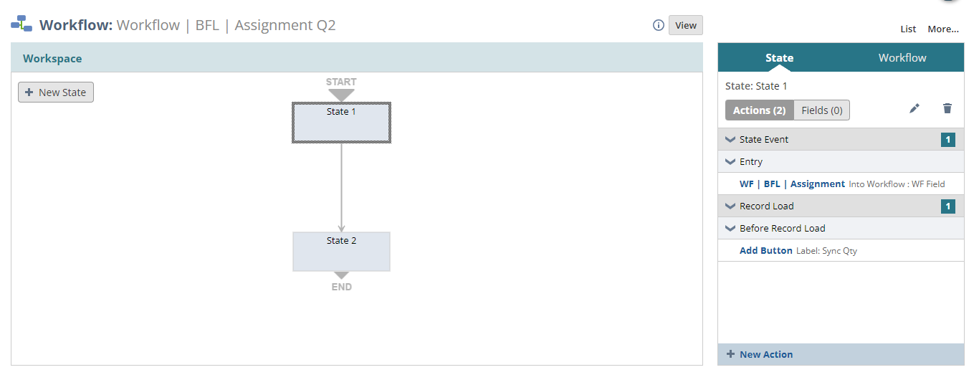

***Code:***

define(['N/record', 'N/log'],

(record, log) => {

const onAction = (scriptContext) => {

try {

var po = scriptContext.newRecord

var total_qty = 0;

var total_line = po.getLineCount({

sublistId: 'item'

})

for (var i = 0; i < total_line; i++) {

var qty = po.getSublistValue({

sublistId: 'item',

fieldId: 'quantity',

line: i

})

total_qty += parseInt(qty)

}

log.debug('Total Quantity', total_qty)

return total_qty

} catch (error) {

log.error('error is ', error)

}

};

return { onAction }

});

Now you can see in the below image that after clicking on the Sync Qty button the net quantity automatically set in the PO Quantity field.

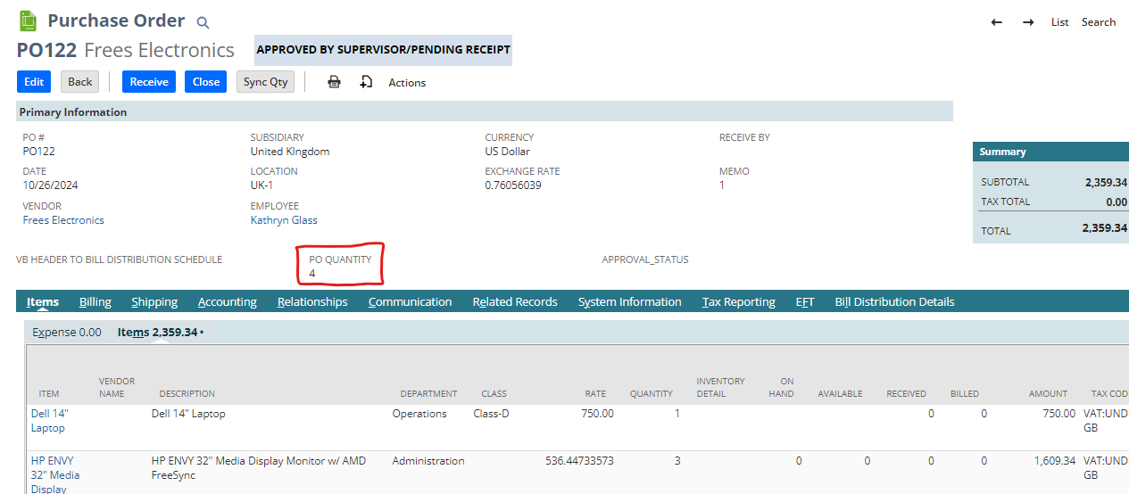

A mail has also been sent to the respective vendor as well.

